**PS2 game joystick**

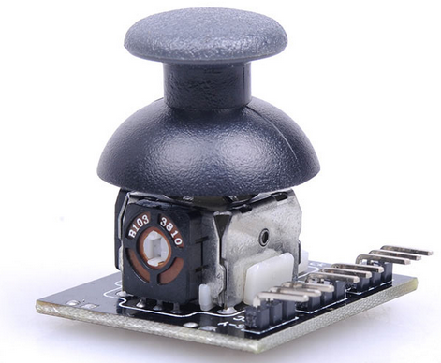

****Description:****  
  
**Lots of robot projects need joystick. This module provides a affordable solution to that. Simply connect to two analog inputs, the robot is at your commands with X,Y control. It also has a switch that is connected to a digital pin. This joystick module can be easily connect to Arduino by normal IO Expansion Shield with supplied cables.  
No soldering required, Reusable for prototyping or design applications of electronic circuit,modify or revise the circuits easily.  
Accept resistors,transistors, diodes, LEDS, capacitors and other types of electronic components.  
An invaluable tool for experimenting with circuit designs whether in the R&D.  
Directional movements are simply two potentiometers - one for each axis  
Compatible with Arduino interface**  
  
  
**Specification:**  
  
**Three axis (X,Y,Z(button))  
Size:37x25x32mm  
Weight: 15 g  
Documents  
WikiDoc  
Tie-point 700  
ABS plastic material  
Completely reusable  
Phosphor bronze nickel plated spring clips  
Accepts a variety of wire sizes(29-20 AWG)  
Size:17.7cm x 4.6cm - 6.97inch x 1.81inch**

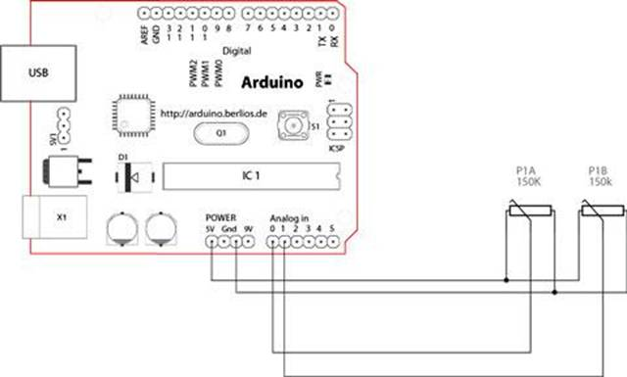

**Test requires：**

**Arduino UNO R3 × 1**

**USB Cable× 1**

**Module × 1**

**X-Analog Pin0，**

**Y-Analog PIN1，**

**Z-Dig Pin7，**

**Code:**

int sensorPin = 5;

int value = 0;

void setup() {

pinMode(7, OUTPUT);

Serial.begin(9600);

}

void loop() {

value = analogRead(0);

Serial.print("X:");

Serial.print(value, DEC);

value = analogRead(1);

Serial.print(" | Y:");

Serial.print(value, DEC);

value = digitalRead(7);

Serial.print(" | Z: ");

Serial.println(value, DEC);

delay(100);

}

It Can show real statues (x,y,z datas)real data to display, as below

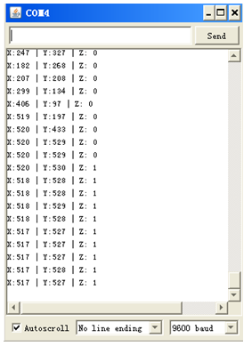

You can also use 2pcs potentiometer and 1pc button to try, below is test code.

int JoyStick_X = 0; //x

int JoyStick_Y = 1; //y

int JoyStick_Z = 3; //key

void setup()

{

pinMode(JoyStick_X, INPUT);

pinMode(JoyStick_Y, INPUT);

pinMode(JoyStick_Z, INPUT);

Serial.begin(9600); // 9600 bps

}

void loop()

{

int x,y,z;

x=analogRead(JoyStick_X);

y=analogRead(JoyStick_Y);

z=digitalRead(JoyStick_Z);

Serial.print(x ,DEC);

Serial.print(",");

Serial.print(y ,DEC);

Serial.print(",");

Serial.println(z ,DEC);

delay(100);

}